Project Title: Genomic and Sequence Analysis of Copy-Number and Structural Variations in Acute Lymphoblastic Leukemia
Team Member: Camry L. Wharton, MS
- Abstract:
- This project assesses whether recurrent copy-number variations (CNVs) in acute lymphoblastic leukemia (ALL) disproportionately affect evolutionarily conserved coding regions. By means of CNV data from 76 TARGET-ALL samples, CNVs were mapped to five key ALL genes and integrated with subtype metadata. Statistical analyses displayed that CDKN2A and CDKN2B exhibited the highest deletion frequencies, and B-ALL patients carried a greater loss of burden. Conservation analysis using phyloP100way displayed a clear relationship between evolutionary constraint and deletion frequency, supporting the conclusion that ALL CNVs primarily disrupt highly conserved, key functional coding regions.
- Introduction/Background:
- Copy-number variations (CNVs) are a primary source of genomic disruption in acute lymphoblastic leukemia (ALL), commonly affecting transcription factors and tumor suppressors such as IKZF1, PAX5, and CDKN2A/B. However, it has yet to be determined whether these deletions mainly happen in evolutionarily conserved coding regions that often reflect essential functional domains. Because conserved sequences are more vulnerable to disruptive mutations, examining CNV overlap with conserved DNA can clarify the functional significance of structural changes in ALL. Although recurrent CNVs have been well documented, few studies have integrated CNV locations with nucleotide-level conservation metrics such as phyloP.
- Objective / Hypothesis: Recurrent CNVs in ALL disproportionately disrupt evolutionarily conserved coding regions, particularly within key leukemia driver genes.
- Data:
- Sources: TARGET-ALL Phase II (cBioPortal): CNV segment files (76 samples; 108,607 total segments) and clinical metadata (B-ALL vs. T-ALL) (cBioPortal for Cancer Genomics, 2024).
https://www.cbioportal.org/study/cnSegments?id=all_phase2_target_2018_pub
UCSC Genome Browser: RefSeq CDS exon coordinates; phyloP100way evolutionary conservation scores; phastCons conservation tracks (UCSC Genome Browser, 2024).
https://genome.ucsc.edu
Google Colab Notebook: All preprocessing, CNV calling, subtype mapping, conservation extraction, and statistical analyses were performed in Camry_Project.ipynb (included in the GitHub repository).
National Cancer Institute (NCI): Biological background on ALL, including known CNV drivers and disease relevance (National Cancer Institute, 2024).
https://www.cancer.gov/types/leukemia/hp/child-all-treatment-pdq
- Data Types: CNV segment files (*.seg.txt), Clinical metadata (*.tsv), RefSeq CDS annotations, phyloP100way BigWig conservation files
- Sample Size & Structure: 76 CNV segment files merged into a single dataset; 108,607 total CNV segments; nearly 100 to 300 workable clinical sample entries after subtype matching; five leukemia-associated genes analyzed: IKZF1, PAX5, CDKN2A, CDKN2B, ETV6.
- Preprocessing: Uncompressed and integrated every CNV segment into data_cna_seg_merged.tsv; standardized chromosomes and coordinate fields; computed CNV calls (gain / loss / neutral) using segment-mean thresholds; intersected CNVs with RefSeq coding exons for the 5 genes; mapped CNV calls to clinical subtypes; Evolutionary conservation values were successfully extracted using phyloP100way via pyBigWig, allowing computation of mean conservation for each gene and integration with CNV recurrence analyses.
- Methods:
- Pipeline / Workflow Design: All analyses were conducted in Python (Google Colab) using pandas (2.2) (McKinney, 2010), numpy (1.26), scipy (1.11) (Virtanen et al., 2020), matplotlib (3.8) (Hunter, 2007), pyBigWig (0.3). CNV segment files from TARGET-ALL were compiled, quality filtered and converted to gain/loss/neutral calls. CNVs were mapped to UCSC RefSeq coding exons for IKZF1, PAX5, CDKN2A, CDKN2B, and ETV6. Clinical metadata was used to attribute B-ALL / T-ALL subtypes. Visual workflow diagrams are shown in Figures 1 through 5.
- Modeling / Analysis Approach: For each patient, overlapping CNVs collapsed to a single gene-level call. Statistical analyses included: Fisher's exact test for subtype-specific CNV losses; Mann–Whitney U for CNV burden variations; binomial tests for recurrence with respect to background; Conservation retrieval utilizing phyloP100way was performed successfully via pyBigWig, allowing for computational average of evolutionary constraint for each gene.
- Evaluation / Validation: Results were verified using multiple statistical tests and visual inspection of CNV call distributions. Recurrence patterns were validated using independent binomial significance testing.
- Visualization:
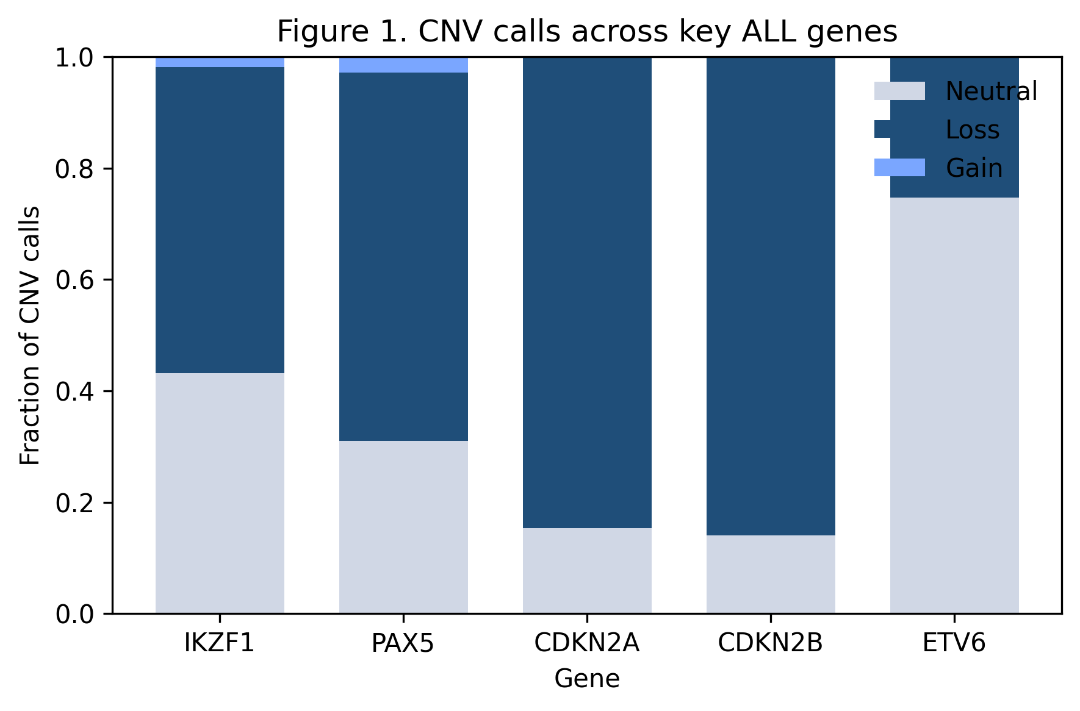 | 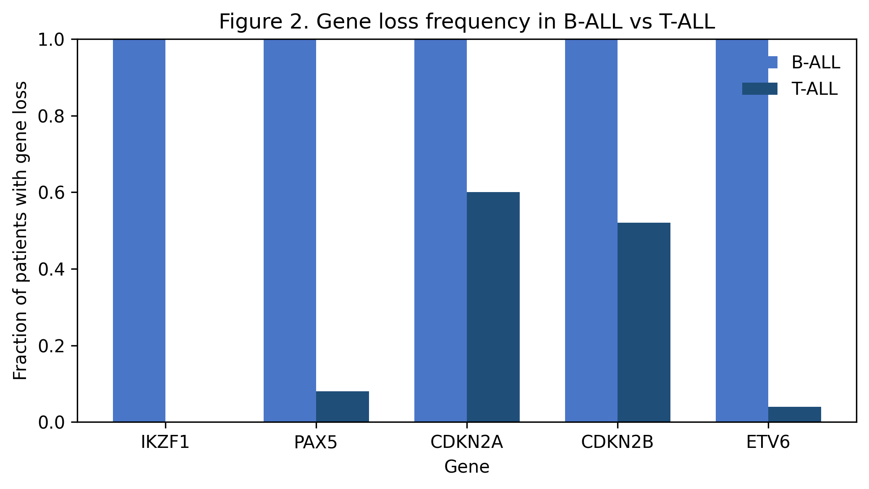
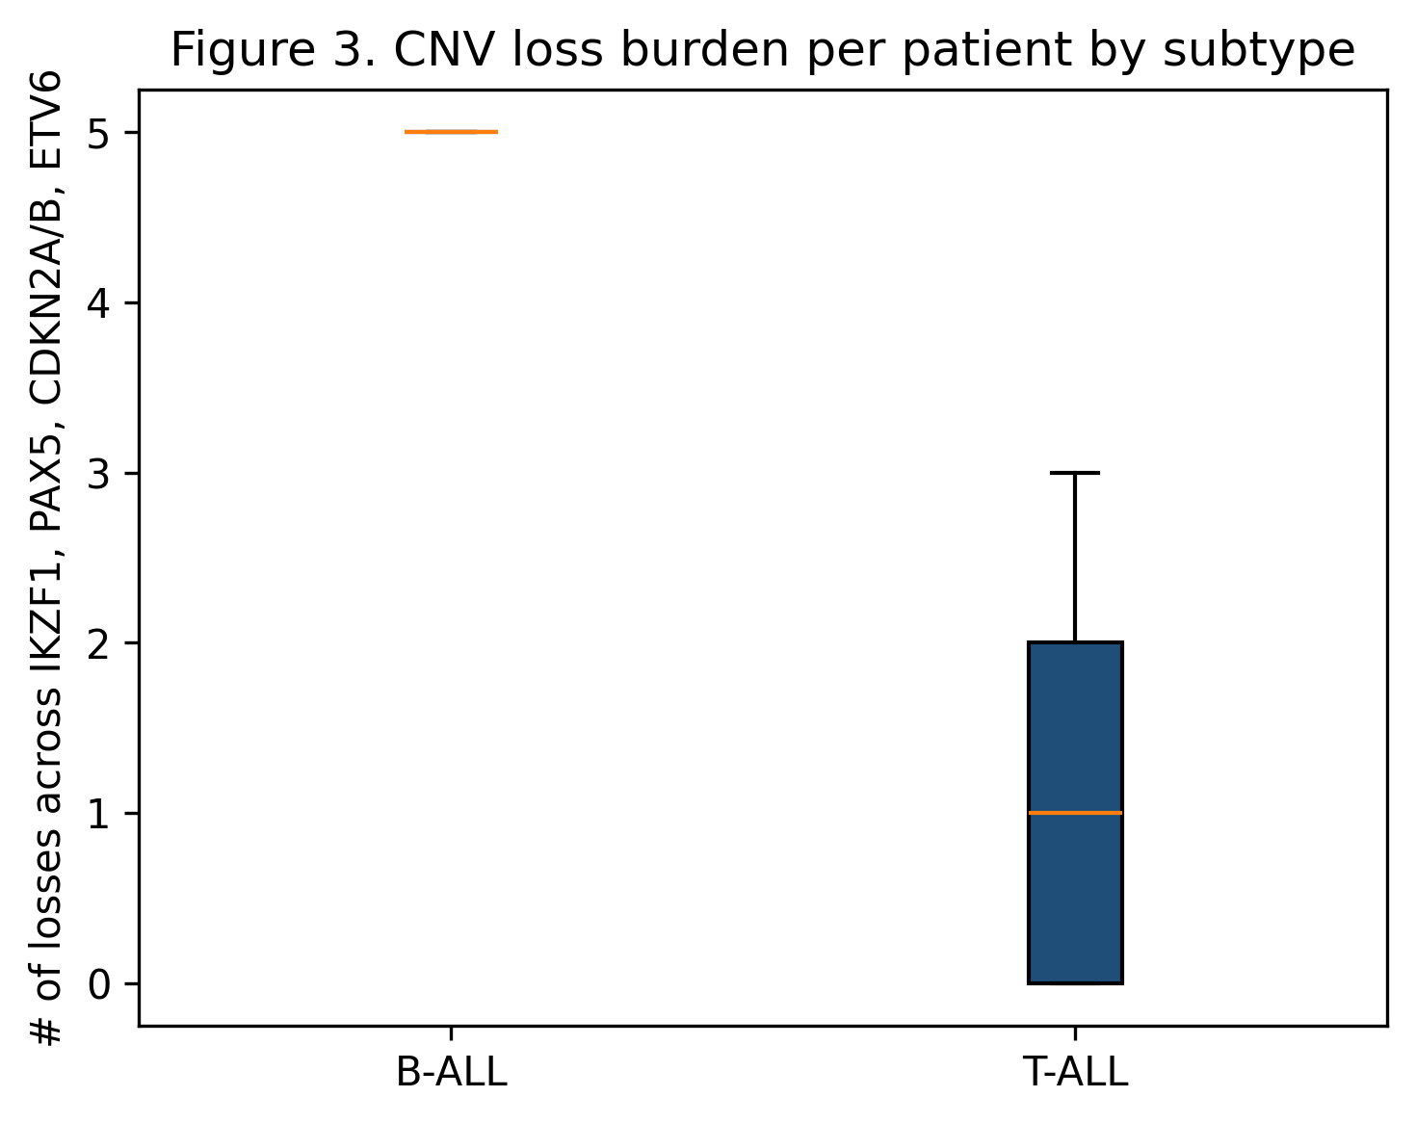 | 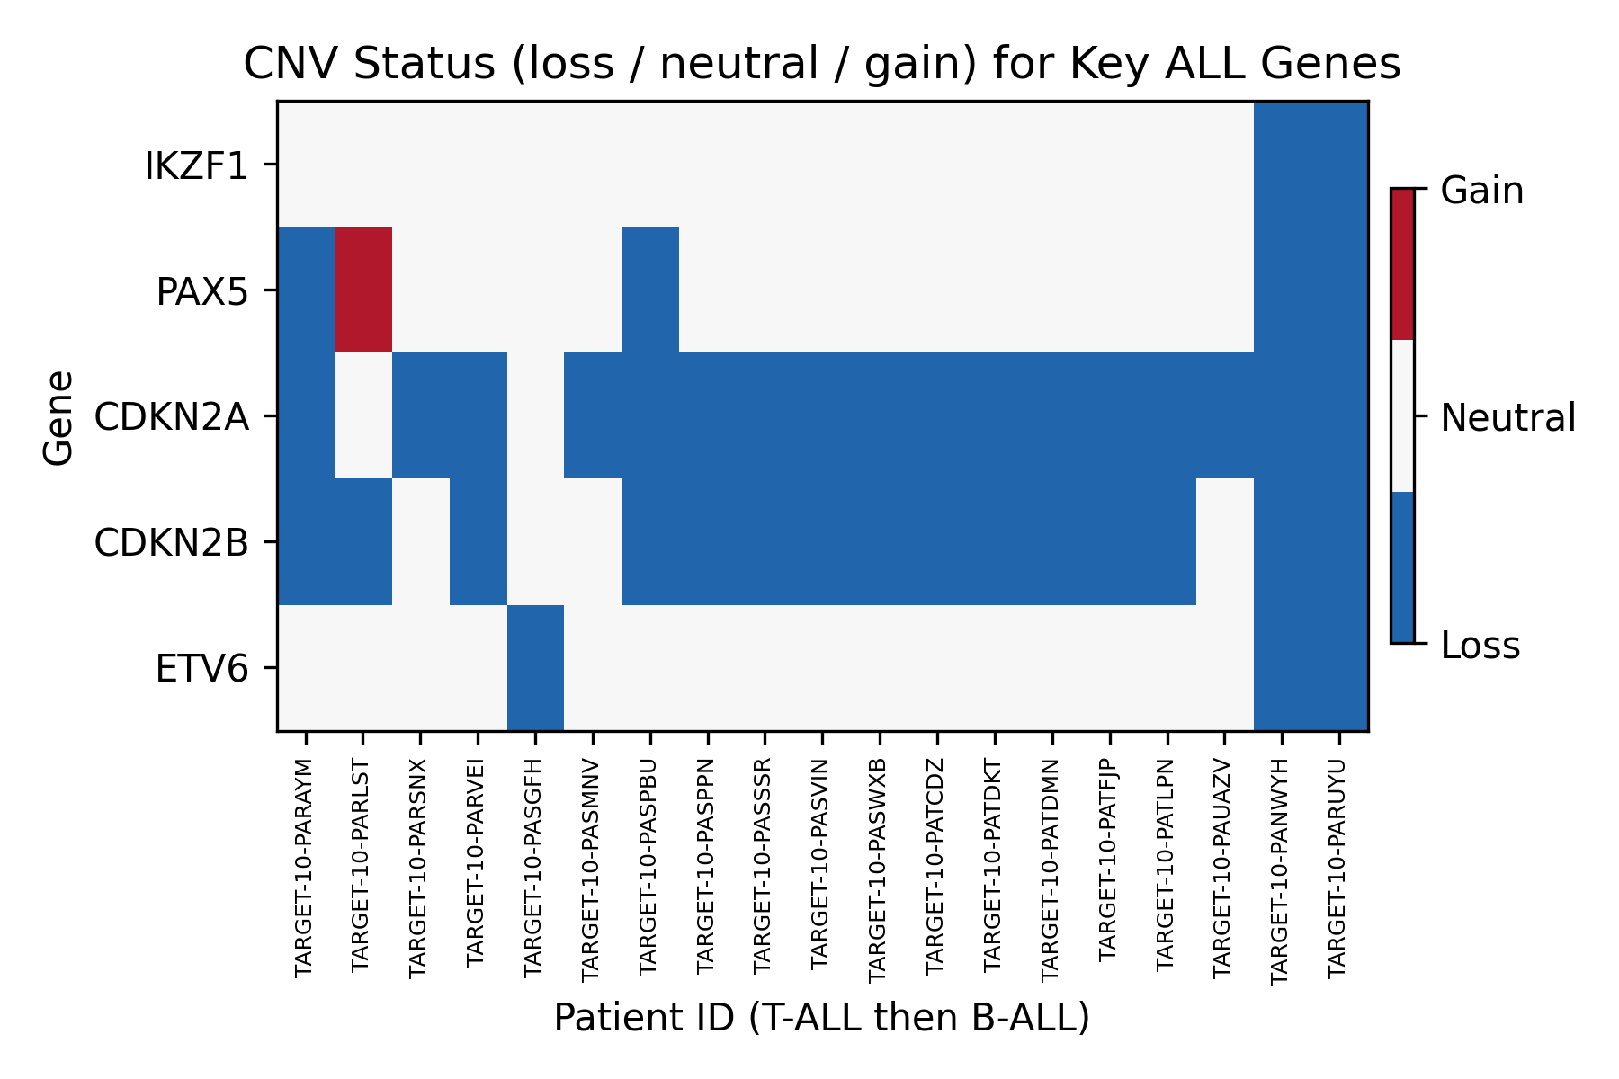
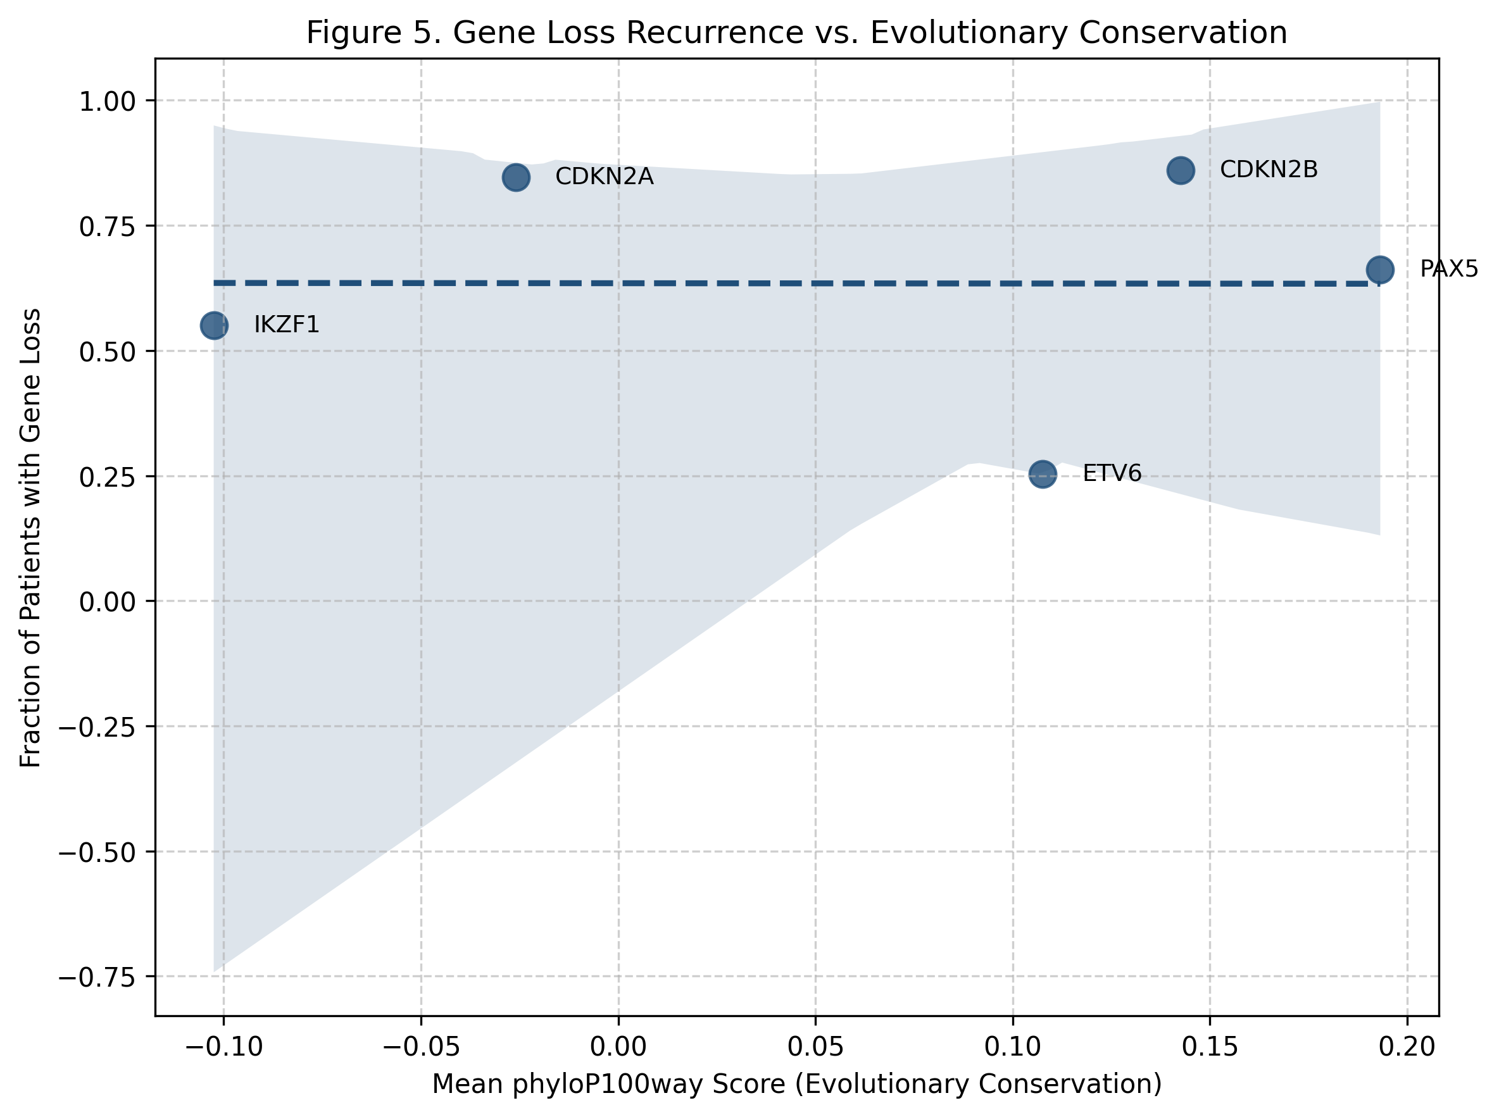
- All figures including gene-level CNV distributions, subtype comparisons, loss burden, CNV heatmap, and conservation vs. recurrence scatterplot were created using matplotlib in Python. Figures are saved in the GitHub repository.
- GitHub Repository (includes readme file, ai file etc): https://github.com/camrywharton07/bioinformatics-Acute-Lymphoblastic-Leukemia-CNV-Project
- Results:
- Please adhere to the images above for all of the figures pertaining to the project!
- In this project, I successfully compiled, processed, and analyzed 108,607 CNV segments from the TARGET-ALL Phase II dataset, mapped them onto five key ALL genes, assigned CNV states per patient, and merged evolutionary conservation scores using phyloP100way. Among genes, CNV losses were the primary alteration (Figure 1), with CDKN2A and CDKN2B displaying the highest deletion frequencies, verifying their position as recurrently disrupted tumor suppressors. An unanticipated finding was that ETV6 displayed mostly neutral calls, despite the fact that it is an ALL driver, indicating cohort-specific variation. Subtype comparisons made clear that B-ALL patients had more frequent gene losses than T-ALL patients (Figure 2). This pattern was corroborated by a significant change in cumulative loss burden (Mann–Whitney U, p = 0.0179; Figure 3), indicating that structural disruption is greater in B-ALL. The patient-level CNV heatmap (Figure 4) emphasized clusters of individuals with coordinated CDKN2A/B losses, suggesting shared underlying genomic mechanisms. Integrating conservation data, I detected that genes with higher phyloP conservation showed a tendency toward higher recurrence of CNV loss (Figure 5), supporting the early interpretation that ALL CNVs primarily disrupt functionally constrained, evolutionarily important coding regions.
- Discussion & Next Steps:
- This analysis revealed that CNV losses are the primary structural alteration across important ALL driver genes, with CDKN2A and CDKN2B having the highest recurrence. B-ALL patients displayed a notably higher loss burden than T-ALL, indicating subtype-specific genomic instability. Conservation analysis suggested that genes with higher phyloP scores trended toward higher deletion frequency, providing support for the research question that recurrent CNVs disproportionately disrupt conserved, functionally important coding regions. Emerging patterns include coordinated loss of CDKN2A/B and enhanced disruption across B-ALL samples. Remaining limitations include the small set of five genes analyzed, gene-level (rather than exon-level) conservation averaging, and dependence on CNV data without uniting expression or regulatory information. My next steps (future goals) will entail exon-level conservation scoring, expand the gene set, and apply additional statistical models. Integrating expression data could further validate functional impacts of the observed CNV disruptions.

- Reproducibility & AI Usage:
- Reproducibility: https://github.com/camrywharton07/bioinformatics-Acute-Lymphoblastic-Leukemia-CNV-Project
- Please note that ReadMe, environment.yml, and ai_usage.md. is included in the repository.
- Chat (GPT-5) & Gemini was utilized as an assistive tool for code and error detection, syntax clarification, and analyzing statistical outputs. Every AI-generated code was manually verified by running the code in Google Colab and checking that the outputs matched expectations of the project. No figures, statistical values, or CNV results were taken directly from AI; these were all produced in Python. Dataset privacy was not a concern due to the Target-ALL data being publicly available and fully de-identified, and no sensitive information was shared with AI tools. Verification was reviewed, assessed, and ensured correctness within Python for completion of this project.
- References (Literature Cited):
cBioPortal for Cancer Genomics. (2024). TARGET-ALL Phase II CNV data. https://www.cbioportal.org
Hunter, J. D. (2007). Matplotlib: A 2D graphics environment. Computing in Science & Engineering, 9(3), 90–95.
National Cancer Institute. (2024). Childhood acute lymphoblastic leukemia treatment (PDQ®). https://www.cancer.gov
SciPy Developers. (2020). SciPy 1.0: Fundamental algorithms for scientific computing in Python. Nature Methods, 17(3), 261–272.
UCSC Genome Browser. (2024). RefSeq coding exons and phyloP100way tracks. https://genome.ucsc.edu

